The Professional Fellows Program between Egypt, Tunisia, Morocco and the U.S.
Theme: NGO Development for Organizations Working with People with Disabilities
administered by
Hands Along the Nile Development Services (HANDS)
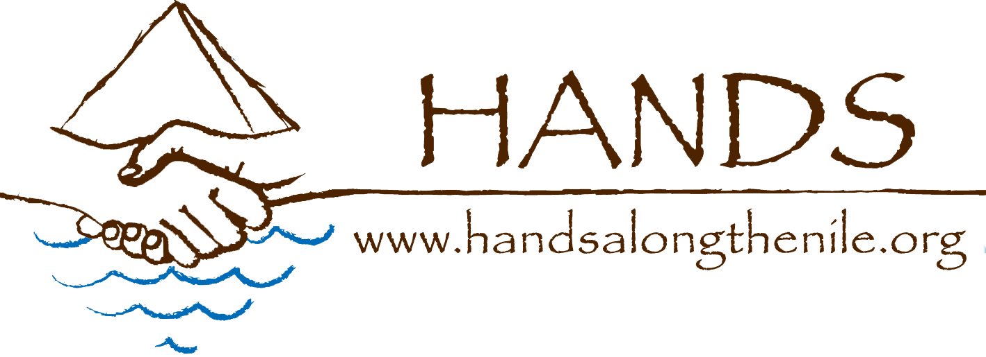
The Professional Fellows Program, funded by the US Department of State Office for Citizen Exchanges in the Bureau of Educational and Cultural Affairs, aims to strengthen the leadership capacity and professional skills of mid-level professionals from Egypt, Tunisia and Morocco engaged with non-governmental organizations who work to improve the status of persons with disabilities. Prior to filling out this application, please read through the eligibility criteria in the Professional Fellow Program Announcement to ensure that you meet the program requirements. Those accepted for this program will travel to Chicago, IL or Seattle, WA in the US from May 2 to June 4, 2016 for fellowships with relevant U.S. based organizations and institutions (NGOs, educational and training institutions, etc.). Following the US-based exchange, selected program participants will continue their involvement with an exchange in Egypt/Tunisia/Morocco in summer 2016, when they and their organizations will continue collaborating with American participants. Selected participants will also be expected to share information acquired through the exchange with their colleagues in home country in order to broaden the impact of this program. By signing this application form, candidates certify their willingness to fulfill the expectations for active and productive participation in this program.
________________________________________________________________________
Please attach a detailed resume and two letters of recommendation to your application form.

The deadline to apply is December 15, 2015.

Applications should be completed in English and submitted by email to:

Professional Fellows Program: pfp@handsalongthenile.org

For further information on program specifics, please visit the HANDS website at www.handsalongthenile.org

For any further questions or concerns, please contact:
Ivana Smucker at ismucker@handsalongthenile.org

APPLICATION FORM

PART 1: BASIC INFORMATION

Name: __________________________________________________________________
first middle last
Permanent Address: ________________________________________________________________________
street city county

________________________________________________________________________
country postal code

Permanent Telephone: _____________________________________________________

Email: __________________________________________________________________

Date of Birth: ___________________ Age: ______________ Male Female
day/month/year

Place of Birth: ________________________ Country of Citizenship: _______________

city and country

Do you have a valid passport? Yes No
If yes, list the number and expiration date: _____________________________________

Do you have dual citizenship? If yes, please specify______________________________

Have you ever traveled or lived anywhere outside Egypt/Tunisia/Morocco? Yes/No
If yes, please provide a brief description including dates and locations:

How would you describe your English skills? (Please list any certificates obtained and courses completed)

Spoken: Excellent Good Adequate Poor
Written: Excellent Good Adequate Poor

PART 2: EDUCATION

Please list any degrees or diplomas earned, name of school, year received

List any additional courses, training, certificates

PART 3: PROFESSIONAL INFORMATION

Title of Current Place of Work: ______________________________________________

Work Address:___________________________________________________________

Telephone/E-mail: ________________________________________________________

Job Title: _______________________________________________________________

What is the annual budget of the organization? ____________________

How many people work in your organization? ___________________________

What percent of your employees are women?______ men? ________ disabled?________

Does your organization have board of directors? If yes, please list how many, and how many of them are male or female; also, how many of them are disabled.

Is your organization registered with appropriate government registering body? What is your registration number ___________

Please provide a basic description of your organization (mission, main programs, how many people reached per year, target groups/beneficiaries):

Please describe your job responsibilities:

PRIOR WORK EXPERIENCE
Please attach your CV with the application.

3. PARTICIPATION IN PFP PROGRAM
Please highlight the information from your resume that describes your current and previous work in improving the situation of persons with disabilities.

In no more than three pages, please present an analysis of the current situation in your organization; main challenges and opportunities, and brief vision/plan for the future as it relates to improving lives of people with disabilities. Please include a reflection on:

1) Three or four central challenges that the disabled in your country are facing (please include here any observations related to the cooperation, or lack thereof, between civil society, private sector and government to address the challenges);

2) Please highlight any achievements and positive steps your organization has made when it comes improving the status of the disabled; indicate if some of these achievements/projects could serve as models that should/could be replicated elsewhere in the region/world; also please indicate three or four major challenges your organization is facing when trying to conduct programs for persons with disabilities.

3) In light of these challenges and successes, please provide your own recommendations to address the identified issues, both through activity on a broader social and policy level and in your own organization.

You can attach your responses on a separate document.

Why are you interested in joining this program, and what do you expect to gain from this experience?

This program involves a four-week fellowship in the US followed by an opportunity to host an American professional at your organization. After completing these two parts of the program, what types of follow-up activities would you propose to pursue to extend the impact of this experience?

Those selected to participate in the program will be expected to develop an individual project idea/plan, to implement in their country upon returning from U.S. based fellowship. This is a mandatory part of the program, please state your willingness to develop and submit to HANDS and your fellowship host individual project plan, and continue to provide updates about its implementation. Examples of types of project include, but are not limited to: development of three year strategic plan; board development plan; staff training (program management, financial management, etc.); writing organizational policy manual, implementing new programs for persons with disabilities, conducting fundraising campaign; starting networks of NGOs working in the same field; etc.

ADDITIONAL INFORMATION

In addition to the educational qualifications detailed on your attached resume, are there any additional courses, trainings, or certificates you have obtained?

Please describe any community service activities you have been involved with.

Please list any leadership roles you have assumed in your professional, educational, or social circles.

Do you have any disability? If yes, please describe the nature of your disability.

Do you use any assistive device? (wheelchair or similar) Please specify.

Do you need any special assistance during the trip to the US? Please specify.

If you are deaf, please state if you understand sign language.

Yes No

Do you understand any other sign language other than Arabic? Please specify.

I agree that all of the information in this application is true and I agree that if chosen to participate, I will participate in ALL program activities in the United States and Egypt/Tunisia/Morocco, and I will prepare individual project plan. I will be able to participate in all aspects of this program.

Applicant Signature Date

