The Professional Fellows Program between Egypt, Tunisia, Morocco and the U.S.
Theme: NGO Development for Organizations Improving the Status of Women
Administered by
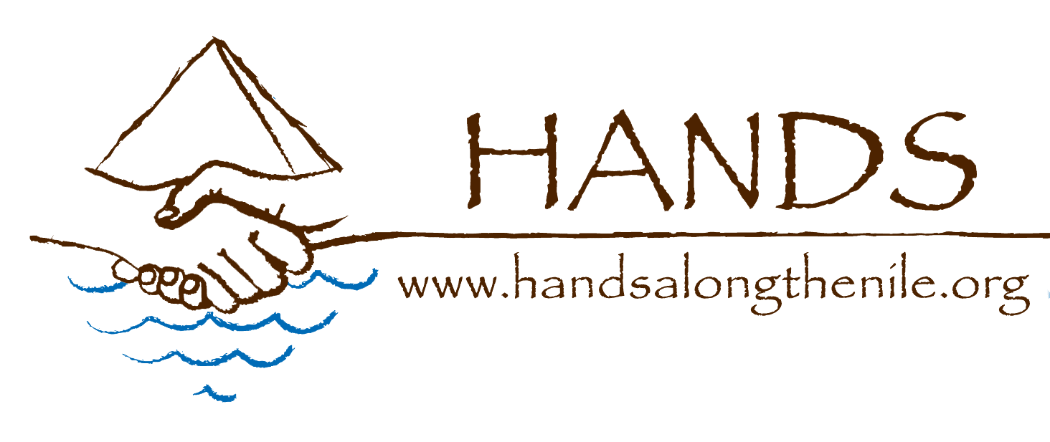
Hands Along the Nile Development Services (HANDS)

The Professional Fellows Program, funded by the U.S. Department of State Office for Citizen Exchanges in the Bureau of Educational and Cultural Affairs, aims to strengthen the leadership capacity and professional skills of mid-level professionals from Egypt, Tunisia and Morocco engaged with non-governmental organizations who work to improve the status of women. Prior to filling out this application, please read through the eligibility criteria in the Professional Fellow Program Announcement to ensure that you meet the program requirements. Those accepted for this program will travel to the greater Washington D.C. area, Chicago, IL, or Seattle, WA in the US from October 16 to November 17, 2017 for fellowships with relevant U.S. based organizations NGOs. Following the US-based exchange, selected program participants will continue their involvement with an exchange in Egypt/Tunisia/Morocco in winter 2018, when they and their organizations will continue collaborating with American participants. Selected participants will also be expected to share information acquired through the exchange with their colleagues in home country in order to broaden the impact of this program. By signing this application form, candidates certify their willingness to fulfill the expectations for active and productive participation in this program.

HANDS values diversity and inclusion in all of our programs. Women, minorities, and individuals with disabilities are strongly encouraged to apply. Reasonable accommodations during the application process and fellowship period can be made available to you upon request.
_____________________________________________________________________________________
Please attach a detailed resume and two letters of recommendation to your application form.

The deadline to apply is April 15, 2017.

Applications should be completed in English and submitted by email to: pfp@handsalongthenile.org

For further information on program specifics, please visit the HANDS website at www.handsalongthenile.com/causes/prospective-professional-fellows/

For any further questions or concerns, please contact:
Payal Sindha at psindha@handsalongthenile.org
APPLICATION FORM

PART 1: BASIC INFORMATION

Name: __________________________________________________________________
first middle last
Permanent Address: ________________________________________________________________________
street city county

________________________________________________________________________
country postal code

Permanent Telephone: _____________________________________________________

Email: __________________________________________________________________

Date of Birth: ___________________ Age: ______________ Male Female
day/month/year

Place of Birth: ________________________ Country of Citizenship: _______________

city and country

Do you have a valid passport? Yes No

If yes, list the number and expiration date: _____________________________________

Do you have dual citizenship? If yes, please specify______________________________

Have you ever traveled or lived anywhere outside Egypt/Tunisia/Morocco? Yes/No

If yes, please provide a brief description including dates and locations:

How would you describe your English skills? Please list any certificates obtained and courses completed in English proficiency.

Spoken: Excellent Good Adequate Poor

Written: Excellent Good Adequate Poor

PART 2: EDUCATION

Please list any degrees or diplomas earned, name of school, year received

List any additional courses, training, certificates

PART 3: PROFESSIONAL INFORMATION

Title of Current Place of Work: ______________________________________________

Work Address: ___________________________________________________________

Telephone/E-mail: ________________________________________________________

Job Title: _______________________________________________________________

What is the annual budget of the organization? ____________________

How many people work in your organization? ___________________________

What percent of your employees are women? ______ men? ________

Does your organization have board of directors? If yes, please list how many, and how many of them are male or female.

Is your organization registered with appropriate government registering body? What is your registration number? ____________

Please provide a basic description of your organization (mission, main programs, how many people reached per year, target groups/beneficiaries):

Please describe your job responsibilities:

PRIOR WORK EXPERIENCE

Please attach your CV with the application.

3. PARTICIPATION IN PFP PROGRAM
Please highlight the information from your resume that describes your current and previous work in women’s empowerment.

In no more than three pages, please present an analysis of the current situation in your organization; main challenges and opportunities, and brief vision/plan for the future as it relates to empowering women. Please include a reflection on:

1) Three or four central challenges that women in your country are facing (please include here any observations related to the cooperation, or lack thereof, between civil society, private sector and government to address the challenges);

2) Please highlight any achievements and positive steps your organization has made when it comes to improving the status of women in your community; indicate if some of these achievements/projects could serve as models that should/could be replicated elsewhere in the region/world; also please indicate three or four major challenges your organization is facing when trying to conduct programs for women’s empowerment.

3) In light of these challenges and successes, please provide your own recommendations to address the identified issues, both through activity on a broader social and policy level and in your own organization.

You can attach your responses on a separate document.

Why are you interested in joining this program? What do you expect to gain from this experience?

After completing the four-week fellowship and exchange program, what types of follow-up activities would you propose to extend the impact of this experience?

Participants selected for this program are required to develop an individual project idea or strategic plan to implement in their country upon returning from the U.S. based fellowship. Do you agree to develop and submit a proposal to HANDS and continue to provide updates about its implementation?

ADDITIONAL INFORMATION

In addition to the educational qualifications detailed on your attached resume, are there any additional courses, trainings, or certificates you have obtained?

Please describe any community service activities you have been involved with.

Please list any leadership roles you have assumed in your professional, educational, or social circles.

Do you have any disability? If yes, please describe the nature of your disability.

Do you use any assistive device? (Wheelchair or similar) Please specify.

Do you need any special assistance during the trip to the US? Please specify.

If you are deaf, please state if you understand sign language.

Yes No

Do you understand any other sign language other than Arabic? Please specify.

I agree that all of the information in this application is true and I agree that if chosen to participate, I will participate in ALL program activities in the United States and Egypt/Tunisia/Morocco, and I will prepare individual project plan. I will be able to participate in all aspects of this program.

Applicant Signature Date

